Resource 5. GPILSEO

GPILSEO at the classroom level
The GPILSEO model can help us to understand what a reform initiative requires if it is to bring about sustainable change within classrooms, and also, what is required if it is to be spread to other classrooms. In terms of GPILSEO this requires:
- Goals: A clear focus on improving the engagement, participation and achievement of the students being targeted by understanding, developing and implementing a pedagogy proven to be effective.
- Pedagogy: A means of implementing this proven pedagogy consistently and with integrity, so that teachers and in turn all students can understand and implement the new practices. This requires teachers understanding the new theories of practice, in their day-to-day classroom relationships and interactions with students and teaching colleagues.
- Institutions: A consideration that pedagogical reform might require new institutions (changes to systems or structures) in classrooms. For example desks in rows might not be the best system for undertaking a more relational, dialogical approach to pedagogy.
- Leadership: A relational, dialogical approach to pedagogy may see different and more distributed opportunities for leadership to emerge. For example it will promote people as being initiators of their own learning and who take responsibility and leadership for supporting the learning of others.
- Spread: New classroom relationships and interactions will need a means whereby they are able to be spread to include all students (across classrooms and across year levels) and all teachers (across departments/faculties) in the school.
- Evidence: A means whereby the progress of all students can be monitored to inform the ongoing changes in instructional. The gathering and examination of classroom evidence provides practice.
- Ownership: New understandings and practices must be owned and understood by all members of the school and they must begin to move out into the community.

GPILSEO at the school level
Changes in classrooms must be coherently aligned at the school level. In terms of GPILSEO this requires:
- Goal: A focus on improving the achievement of all targeted students across the school.
- Pedagogy: A culturally responsive pedagogy of relations developed across all classrooms, that is then able to be used to inform relations and interactions at all levels within the school and community
- Institutions: In order to support this reform, time, resourcing and space must be reprioritised for the development of any new institutions at the school required to support the goals and new pedagogy within classrooms. Organisational structures, such as timetables, staffing, meetings, curriculum implementation and student management systems, may all need to be considered.
- Leadership: Leadership that understands and is responsive to the wider social implications of a reform of this kind. Leadership that is also proactive and distributed to ensure GPILSEO is understood and applied across the school’s leadership teams.
- Spread: A means whereby the reform can be spread to include all staff, and where parents and community can also participate.
- Evidence: Specific tools, to monitor the implementation of the reform and provide data for formative and summative purposes, must be developed/accessed and able to be used smartly.
- Ownership: The whole school, including the board of trustees, must take ownership of all aspects of the reform.

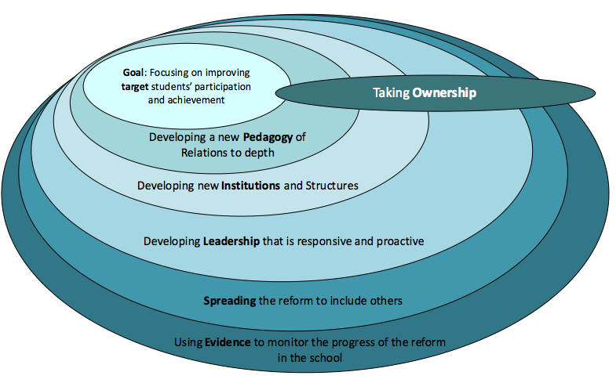
Figure 6: GPILSEO MODEL

